**Game Controller with Arduino**

**Group Members**

**Rishav Goswami, RA2411003011303, B.Tech CSE Core, A2 Section**

**Rahul Singla, RA2411003011299, B.Tech CSE Core, A2 Section**

**Shivang Thakkar, RA2411003011298, B.Tech CSE Core, A2 Section**

**Yuvraj Singh Rana ,RA2411003011300, B.Tech CSE Core, A2 Section**

**Vamsi Krishna Yachamaneni, RA2411003011304, B.Tech CSE Core, A2 Section**

**Saransh Sudan, RA2411003011302, B.Tech CSE Core, A2 Section**

**Dharshini Praveen Kumar, RA2411003011301, B.Tech CSE Core, A2 Section**

**G Varshaa, RA2411003011306, B.Tech CSE Core, A2 Section**

College of Engineering & Technology,

SRM Institute of Science and Technology, Kattankulathur, Chengalpattu Dt, Tamil Nadu

**Faculty Incharge**

**Vijayakumar T**

**Name of the Faculty**

Department of Physics and Nanotechnology, College of Engineering & Technology,

SRM Institute of Science and Technology, Kattankulathur, Chengalpattu Dt, Tamil Nadu

**Summary:** A Game Controller is used to control the player’s movement and direction in a game.

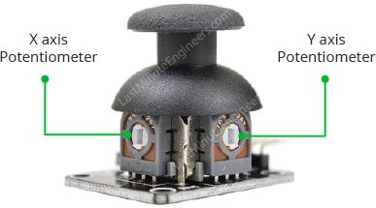 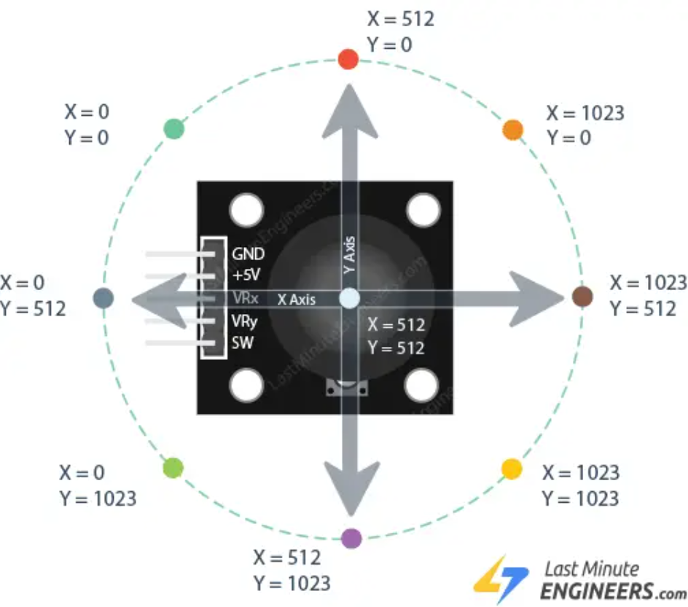

Using a 2-way joystick which has two potentiometers, we can read the analog values which are hooked to the Arduino. Using the analog values, we can determine the direction the player has to move towards through a python code.

**Joystick Mapping**

1. Case 1: x=0 & y = 512 **means** player moves to the left
2. Case 2: x=1023 & y = 512 **means** player moves to the right
3. Case 3: x=512 & y = 1023 **means** player moves back
4. Case 4: x=512 & y = 0 **means** player moves forward

Hence, we can control the player this way.

This is all possible with the help of analog values that we read from the Arduino.

The analog values is read by python as a tuple (x,y)

According to the above cases, it is possible to control player movement through this communication between the Arduino circuit and the device.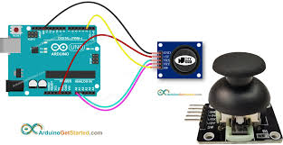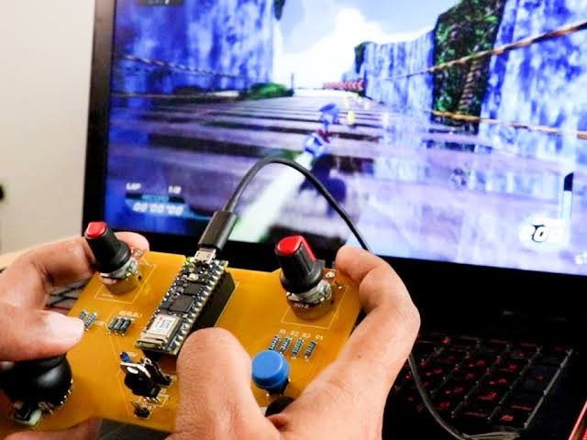

Figure. **Overview circuit of the game controller**